

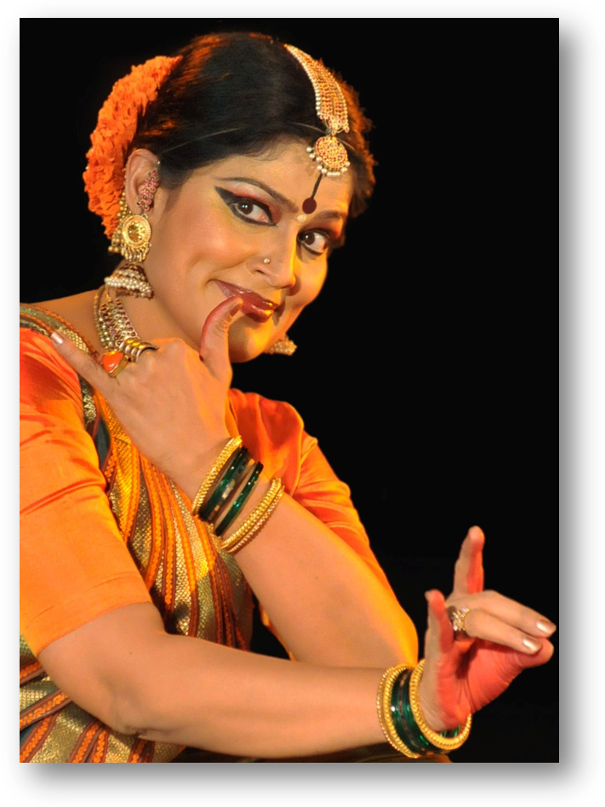
(Padmashri) GEETA CHANDRAN
Dancer/Choreographer

A celebrated artist and a star-performer, Geeta Chandran is synonymous with the Indian classical dance: Bharatanatyam. She began learning Bharatanatyam from the tender age of 5 years under the tutelage of Smt. Swarna Saraswathy, who hailed from the traditional Thanjavoor dasi parampara. Subsequently, Geeta continued learning diverse aspects of the classical dance from a galaxy of eminent Gurus.

Today she is a renowned artist who has synthesised the knowledge she received from her Gurus to imprint Bharatanatyam with her personal vision of the dance. In her dance presentations Geeta Chandran skilfully weaves abstract notions of Joy, Beauty, Values, Aspirations, Myth and Spirituality.

A polymath artist, Geeta is celebrated not only for her deep and composite understanding of the art of Bharatanatyam, but also for her Carnatic music (she is a trained and accomplished vocalist), her work in television, video and film, theatre, choreography, dance education, dance activism and dance-issue journalism.

Geeta Chandran’s specialty is Bharatanatyam Abhinaya, a journey that she began at the feet of her first Guru who was called “Abhinaya Saraswathy”. Subsequently Gurus Jamuna Krishnan and Smt. Kalanidhi Narayanan helped her hone her abhinaya to a fine art. Geeta’s Junior Fellowship from the Ministry of Culture was for a project on Vachika Abhinaya, which linked her dance to her long years of training as a Carnatic vocalist. Her Senior Fellowship from the Ministry was for Haveli Sangeet, where she integrated poetry and pads from northern devotional poets into the Bharatanatyam repertoire.

An A-Top graded dancer at Doordarshan and at the Indian Council for Cultural Relations (ICCR), Geeta is recipient of several prestigious awards including the Lady Shri Ram College Illustrious Alumna Award, the Dandayudhapani Pillai Award, the Bharat Nirman Award, the Natya Ilavarasi, the Indira Priyadarshini Award, the Media India Award, the National Critics Award, the Sringar Mani and the Natya Ratna.

Founder-President of Natya-Vriksha, an organization devoted to promoting Bharatanatyam, Geeta has evolved a holistic style of teaching the classical dance which engages young learners. She has presented the arangetrams (debut performance) of over 30 senior disciples who continue their training under her and she continues to mentor over one hundred disciples; several of her students have blossomed as full-fledged performers.

Geeta Chandran is also Artistic Director of the Natya Vriksha Dance Company, known for the high aesthetic quality of its group presentations. She has travelled all over the world with her performances and has danced at many prestigious dance festivals in India and abroad. In 2007, she was invited to perform at the World Hindi Conference in New York, and then again to represent India at the India-60 celebrations at the Lincoln Centre in New York. She was invited to travel all over the UK as part of the celebrations of 60 year of the Indian Republic.

Geeta has constantly striven to create new spaces for the classical dancer of today. She has continuously attempted to push the frontiers of the classical art and to reach out to new, and especially young, audiences. Geeta believes that dance must be linked to life and that artists must use their unique position in society to make a difference to life and living. Her choreographies HER VOICE and IMAGINING PEACE articulated her conviction that dance can be a vehicle to build social bridges. Her widely acclaimed dance-theatre production KAIKEYI and her choreographies on the themes of DRUGS have thrown the spotlight on issues of social stigma. Her 2008 work -- MYTHOLOGIES RETOLD -- addressed the social curse of female feticide. She is also known for using classical Bharatanatyam to amplify gender and environmental issues. Her most recent work GANDHI: Warp and Weft is hailed for spotlighting minimalism in Indian dance choreography.

In expanding the frontiers of her classical dance performances, Geeta Chandran has collaborated with a wide range of dancers, musicians, craftspersons, authors, writers, poets, painters, theatre-personalities, academicians, philosophers, linguists and costume & fashion designers.

Geeta is associated with several NGOs and charitable organizations raising resources for valuable causes, among them peace, environment and peace. She is well-known for her association with philanthropic causes, and has presented innumerable performances to raise funds for worth social causes. She is most especially identified with gender issues and poverty.

Geeta has authored a book SO MANY JOURNEYS, an intensely personal collection of her writings narrating her engagement with Bharatanatyam.

A widely respected role model for the young generation, Geeta guides reputed national cultural institutions and prestigious universities as their Board member, and she also serves on the Advisory Boards of several reputed schools and colleges. She engages in the widest range of dance-related activities: performing, teaching, conducting, singing, collaborating, organizing, writing and speaking to new youth audiences.

In recognition of her vast and varied contribution to Bharatanatyam, Geeta was awarded the prestigious national award -- the Padma Shri -- by the President of India in 2007.

www.geetachandran.in

