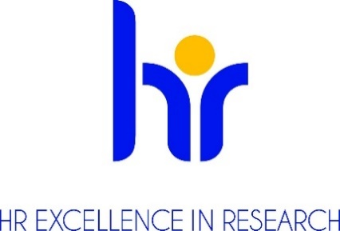

AMU European Charter and Code Implementation Group

Steering Committee
prof. dr hab. Katarzyna Dziubalska-Kołaczyk - professor, Vice-Rector for Research, Leading Researcher R4
prof. dr hab. Przemysław Wojtaszek - professor , Vice-Rector for Research Projects and Doctoral Studies, Leading Researcher R4

prof. dr hab. Tadeusz Wallas - professor , Vice-Rector for Human Resources and Development, Leading Researcher R4

Working Group

prof. UAM dr hab. Krzysztof Dyczkowski - university professor, Established Researcher R3
prof. dr hab. Robert Kmieciak – professor, Leading Researcher R4
prof. UAM dr hab. Wojciech Sowa, university professor, Established Researcher R3
dr Joanna Morawska-Jancelewicz - assistant professor, Recognised Researcher R2
dr Anna Kasprowicz-Maluśki - assistant professor, Recognised Researcher R2
mgr inż. Adam Młynarczyk - doctoral student, First Stage Researcher R1

dr Marcin Wysocki – Administrative staff, Chancellor
dr Aleksandra Bocheńska - Administrative staff, Head of Legal Affairs and Organisation Office
dr Dominika Gapska- Administrative staff, School of Languages and Literatures - Main Office
mgr Katarzyna Linke - Administrative staff, Director of Human Resources Centre
dr Anna Stachowiak-Szrejbrowska - Administrative staff, Head of Grant Application Support
dr Magdalena Szafran - Administrative staff, Head of Science Support Office
mgr Katarzyna Wala - Administrative staff, Marketing Centre

