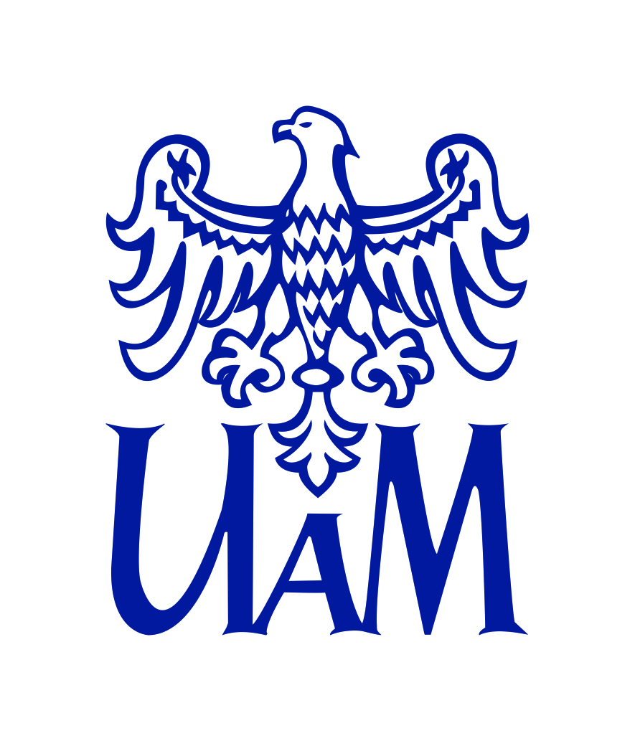
UI GreenMetric World University Rankings (UIGWURN) Report 2021

Country: Poland
National Coordinator: Adam Mickiewicz University, Poznań

I General
AMU is a centre of academic excellence where research and teaching are mutually sustaining. AMU's mission is to advance knowledge through quality research and teaching
in partnership with business and public services. AMU is one of ten research universities in Poland, strongly oriented to the development of scientific research and their internationalization.
AMU aspires to contribute to economic growth, social development and environmental sustainability in Central Europe. We are a part of EPICUR Alliance (European Partnership for
an Innovative Campus Unifying Regions) together with 7 European universities from Austria, Germany, Greece and France, what opens new perspective to our students and researchers.
The University continuously extends and updates research programs and contents of study curricula, with special emphasis on their interdisciplinary and international nature.
II Sustainable Development Activities
1. Climate Action
1.1 The concept of the Green University
The goal of the Green University program is incorporating the principles of sustainable development into AMU mission. The project promotes and protects natural areas and biodiversity, supports environmental initiatives, promotes healthy lifestyles, waste segregation and conservation
of natural resources.
It covers activities in 6 areas:
- research and teaching – carrying out interdisciplinary research projects on sustainable development, applying the acquired knowledge and using it in education and practice,
- functioning – protection and improvement of the quality of the environment by minimizing the impact of the functioning of the University,
- shaping space – protection and enhancement of biodiversity and development
of the ecological structure by introducing Nature Based Solutions,
- shaping sustainable development behaviour and culture – encouraging AMU community
to take actions that have a positive impact on their life by caring for health, shaping social bonds and collectively shaping good practices in the field of sustainable use
of environmental resources,
- management and coordination at the University – strengthening and developing
the consistency of AMU administration with the principles of sustainable development and coordination of activities in this area,
- monitoring – defining methods of including the evaluation of the implementation
of the SDGs into the reporting system at the University, as well as participation in national and international rankings.

  - IDEAMU competitions
The idea of Green University has been promoted through the IDEAMU competitions held at AMU, which aim to develop green and social innovations and strengthen lasting relations between
the University and its surroundings. So far awarded projects concerned:
- the equipment of the campus with nest boxes, houses, and insect hotels for a variety
of animals who live in urban environments,
- creating a guide to good practices for socially responsible and environmentally friendly scientific conferences,
- developing solutions for preventing paper waste, rational water management and reduction of the use of disposable plastic in academic contexts.
1.3 International consortium TeRRIFICA
The AMU belongs to an international TeRRIFICA (Territorial RRI Fostering Innovative Climate Actions) consortium project. The aim of the project is implementing innovative solutions
for improving the climate change management process through regional innovation networks
in various European countries. With the use of a specially created crowd mapping tool, scientists obtain knowledge about severe climate changes from residents and then, based on the collected data, work with them on solutions designed to limit or adapt to climate change.
1.4 AMU Astronomical Observatory
AMU Astronomical Observatory Institute is the leading Polish unit in a European consortium that has been set up in Europe to develop a US-independent system for the detection and tracking
of artificial satellites and space debris, threatening both human safety and the global economy.
The CLEANSPACE project developed at the Observatory is aimed at cleaning up of the Earth’s orbit with the use of a high energy laser to incinerate space debris in the atmosphere. In 2020
in The Dark Sky Park near Sieraków, 5 AMU telescopes were set up. Their main purpose is to monitor the immediate vicinity of the Earth, determine the flight trajectory of space debris, as well as time and place of its eventual fall onto the Earths’s surface.
1.5 AMU Polar Station
The AMU Polar Station in Spitsbergen consists of three houses in the bay of Petuniabukta built
by scientists who study geological processes, observe the tundra, and monitor the glacial melting process. Thanks to the inclusion of the unit in the INTERACT project of the European Union’s Horizon 2020 program, the station is hosting international research teams in an effort to develop research cooperation in the Arctic.
1.6 Polish Archaeological Institute at Athens
The Polish Archaeological Institute at Athens is a branch of Adam Mickiewicz University
and represents the interests of all Polish scientists conducting research in Greece. The facility
is open to archaeologists as well as historians, art historians, Byzantium scholars, classical philologists and other researchers. The Institute will serve as a centre for the promotion of Polish science and culture in Greece.
1.7 AMU Botanical Garden
Between 2016 and 2019 AMU Botanical Garden participated in an international Botanical Garden: COME IN! VSTUPTE! KOM IN! WEJDŹ! GYERE BE! project, including botanical gardens across Europe. The project was dedicated to the accessibility of botanical gardens to people with special needs
and developed a methodology for working with such visitors.
For many years, AMU Botanical Garden has also been participating in the global plant seed exchange program. In order to protect endangered species, conditions have been created for the storage of seeds from all over the world, including devices enabling their storage at low temperatures. The seeds are listed in Index Seminum – special catalogues which constitute a sort
of bank of genes, which are sent to nearly 300 botanical gardens around the world.
1.8 Researchers for the climate
Hydrogeologist Prof. Józef Górski is an expert on the quality, monitoring and protection
of groundwater. The scientist is actively involved with the issue of water retention
in the environment and, in particular, in the importance of small water retention for groundwater and surface water levels and quality. Prof. Górski implemented a modern and cost-efficient method of groundwater treatment in the aquifer that removes iron and manganese from the water.
His designs and methodologies have been successfully applied in multiple water intakes across Poland.
Dr Emerson Coy’s research deals with the designing and understanding of novel solutions
for catalytic converters installed in cars, trucks and buses. He believes designing highly functional nanomaterials with outstanding mechanical properties is crucial for both long-lasting operation
and improved applicability of catalytic converters. Strong, highly catalytically active, flexible, thermally stable at high temperatures and cost-effective energy nanomaterials used in catalytic converters would prevent environment from pollution by iridium and platinum – catalytic converters’ main components.
To read more about AMU researchers see the publication: Engaged University
2. Quality of education
2.1 Poznań Festival of Art and Science
Poznań Festival of Art and Science is an academic celebration that promotes science and art among the inhabitants of Poznań. Each year there are over 300 events, including shows, seminars, workshops and lectures conducted by top experts and scientists keen on sharing their passion.
The festival has been organized annually for over 20 years!
2.2 Researchers' Night
The European Researchers' Night is a Europe-wide public event, which displays the diversity
of science and its impact on citizens' daily lives through a wide range of science shows, hands-on experiments, games, quizzes, competitions, exhibitions and digital activities. Each year
in September AMU researchers show what they really do for society in interactive and engaging ways, promoting research careers to young people and their parents.

2.3 Open University
AMU Open University is a great example of the university’s involvement in its third mission. Open University courses are addressed to people who want to expand their knowledge, hobbyists who want to develop their passion in an academic environment and young people such as high school graduates. Every semester dozens of courses are offered and hundreds of students take part.
2.4 KOLaboratorium
The KoLaboratorium program expands the range of interests of the inhabitants of Poznań
and the Wielkopolska region by teaching them marketable skills and expertise. The project is unique because of the number of involved AMU faculties and entities, the variety of topics covered across more than forty courses, and the innovative teaching.
2.5 Bilingualism Matters
Bilingualism Matters@Poznań is a research and information centre at the AMU Faculty of English and is one of the 23 international branches of the University of Edinburgh’s Bilingualism Matters.
It conducts research on bilingualism and multilingualism hosts regular workshops and lectures promoting knowledge about bilingualism and multiculturalism among the local communities and offers consultations with specialists, including speech therapists, psychologists, educators and scientists, and open up space for a broad social discussion.
2.6 Children’s University ”Kolorowy Uniwersytet”
AMU Children’s University promotes science by helping primary school pupils develop their creative and intellectual potential. During the academic year, children enrolled at the university participate in meetings with scientists, who teach them about a variety of scientific fields and instil a passion for science. Courses cover a range of disciplines, from natural sciences to the humanities.
2.7 MENTORusznik programme
MENTORusznik is a mentoring program in which students from AMU become mentors for the students from one of the Poznań high schools. The main goal of the program is to support young people in their educational, professional and personal development through the exchange
of experiences and learning with the use of activating methods, going beyond formal education. The participants worked for several months on the implementation of their previously established development goals.
2.8 Sustainable Development Academy
The Academy is an interdisciplinary project aimed at popularization of the scientific and didactic activity of AMU employees in the context of the 17 UN Sustainable Development Goals. Scientists from various disciplines talk about their research during short lectures, enriched with photos and films, highlighting the goal of sustainable development they concern. Film materials are presented free of charge on-line in social media, on YouTube and AMU website.

3. AMU in the time of pandemic
3.1 Research on COVID-19
Prof. Jakub Rybka is the deputy head of AMU Centre for Advanced Technologies that works on new materials and biomaterials with broad applications. As his research bioprintable autologous meniscus was halted shortly after the outbreak of the coronavirus pandemic he and his colleagues decided to undertake a new challenge and start working on the development of an autoimmune test for COVID-19. A pilot study was successfully conducted and the test was able to verify
the presence of antibodies in patients. This is the first milestone on the road to universal immunological diagnosis of COVID-19.
Prof. Mariusz Jaskólski is a crystallographer and structural biologist. He uses diffraction of X-rays on crystallized proteins and nucleic acids to study the their three-dimensional architecture.
As a scientist, he commited in discovering the structure of retroviral enzymes (e.g. HIV protease, leukemia protease, integrase), the structure of bacterial asparaginase (an important antileukemic protein). Professor Jaskólski also explained the mechanism of aggregation of an amyloidogenic protein responsible for lethal cerebral angiopathy. The scientific research conducted by Professor Jaskólski has advanced our understanding of the molecular mechanisms of several diseases
and stimulated rational, i.e. structure-based, approach to the design of new drugs and therapies.
In March 2020, shortly after the introduction of pandemic-related restrictions, a team
of sociologists and students from Adam Mickiewicz University led by Prof. Marek Krajewski carried out a study which evolved into a complex long-term research project devoted to everyday life
in Poland during the COVID-19 pandemic. The researchers study how society adapted
to the situation, how ordinary people’s lives and daily routines changed immediately
after the introduction of sanitary restrictions and how the pandemic is seen from the perspective of time.
Biologist Dr. Paweł Zawadzki and his team participate in the international consortium project
The COVID Human Genetic Effort. The consortium’s discovery that genes influence the course
of disease caused by SARS-CoV-2 virus will help to select both people genetically resistant
to the virus and people who are particularly vulnerable to severe disease.
Psychologist Prof. Grzegorz Króliczak participated in an international research group that proposed a new effective way next to the lock-down and vaccines, to control the reproduction of the SARS-CoV-2 virus. The scientists' proposal focused on recognizing and modifying attitudes by motivating pro-health behaviours. Their research has shown how to achieve better rates of compliance
with the regulations, without external coercion.
3.2 The Visible Hand
This action was the result of an ordinary heart reflex. As part of Visible Hand, AMU staff has collected lots of things to support the work of the medical team of the COVID-19 hospital in Poznań.
3.3 AMU speaks
AMU Speaks was a series of short, live lectures that premiered on March 20th, 2020
on the Facebook profile of Adam Mickiewicz University and YouTube channel. AMU Speaks reached out to all those who had found themselves with a lot of free time due to the coronavirus pandemic. They were also intended to help students whose classes had been suspended. The subject matter ranged from positive emotions, through algorithms, to waterbears and the series turned out
to be a hit among the audience.
3.4 AMU moves!
AMU moves! was a sport game carried out in spite of the pandemic by the AMU Study of Physical Education and Sport. For one month, running, walking, roller skating or riding a bicycle, AMU students and employees could break new life records by competing between AMU departments. Data collected through a dedicated application allow to conclude that the participants of the game circled the planet twice during a month, covering 86,400 km.
III AMU as a National Coordinator in Poland
1. Polish Universities included in IU Green Metric World University Rankings
1.1 Gdańsk University of Technology
General
Gdańsk Tech contributes to solve the main challenges of the contemporary world – climate changes, shrinking supplies of natural resources, population ageing, human migration, inefficiency and disparity of healthcare and other – starting with the local context (”think globally, act locally”).
Gdańsk University of Technology activities correspond to the SDG’s. More than 200 subjects
are related to environment and sustainability. Gdańsk Tech actively participates in seminars regarding Sustainable Development and promotes its engagement by preparing a website
and reports showing the research and teaching in the field of sustainable development
at University.
The social commitment is reflected in the architecture and functionality of the University's campus, shaped in accordance with the principles of sustainable development and widely accessible
to students, staff, and visitors with functional diversity.
Sustainable Development Activities
- Open Gdańsk University of Technology (OPEN Gdańsk Tech)
OPEN Gdańsk Tech offers numerous scientific and cultural events to the residents of the Tri-City and the surrounding area as well as for the academic community. The most recognizable projects are:
- European Night of Museums,
- the summer Open-Air Concert in front of the University's Main Building,
- #CiekawiNauki (eng. #ScienceCurious) – a series of meetings addressed to people interested in science-related topics,
- the Scientific afternoons with Gdańsk University of Technology broadcast series
on Radio Gdańsk.

- Multigenerational University of Technology
It’s an educational project for children, young people, adults and seniors, offering free, practical educational workshops and lectures in science, socio-economic sciences, new technologies,
and ecology in multi-generational classes dedicated to parents with children and grandparents with grandchildren. School groups and people with special needs can also benefit from the offer
of classes.

- The Volunteer Center
The university authorities launched the Center to popularize the idea of volunteering
in the academic community. It was established on the basis of an agreement concluded
with the Regional Volunteer Center, and at the same time signed a declaration
of cooperation with the city authorities for the development of volunteering in Gdańsk. Under the Volunteer Center of Gdańsk Tech, 3 main aid areas of sharing knowledge, skills and helping others have been created:
- educational volunteering,
- event-based volunteering,
- multicultural volunteering.

- #GdańskPomaga (eng. #GdańskHelps)
#GdańskPomaga (eng. #GdańskHelps) campaign is an initiative established in connection
with the COVID-19 pandemic. This campaign brings real help to all those who are hindered
or prevented from functioning by the epidemic threat: the elderly, students, healthcare
and hospital services;

- The Baltic Science Festival
The festival, organized by the University for nearly twenty years, is addressed to a wide group of recipients living in the Pomerania region, regardless of their education and age. The festival program includes about 150 scientific conferences and picnics, shows, workshops, panel discussions, lectures, presentations of experiments, visits to laboratories, scientific outdoor trips and many other interesting events.
Furthermore, Gdańsk University of Technology established the Ekotech Center (which deals
with shaping a harmonious, sustainable space for human life in the face of current environmental challenges, climate change as well as social and demographic changes) and is in the process
of construction of Gdańsk Tech Eco-innovation Center (a scientific unit working
on the development of pro-ecological solutions and environmental technologies aimed
at implementing innovative solutions in line with the idea of building eco-cities and ecological spaces).

More on Gdańsk Tech initiatives:
Local Community
Multigenerational University of Technology
The Volunteer Center
COVID-19 – You Can Help!
Baltic Science Festival
Baltic Sea Region Universities’ Seminar on Sustainable Development
EkoTech Center
Eco-innovation Center

1.2 Cracow University of Technology
General
Cracow University of Technology promotes science and the development of interests in technical and exact sciences. 10 original educational projects of the University of Technology worth nearly PLN 10 million will be implemented as part of the ”Third Mission of the University” competitions.
Sustainable Development Activities
- University of the Third Age
The lectures offered by the University are addressed to the elderly. Nearly 300 students participate in symposiums, held every two weeks, as well as in seminars in small groups, where they gain knowledge of foreign languages, computer skills, pedagogy and psychology, history
of arts and film. Moreover, they participate in recreational and physical activities.

- Children’s University
The project, run in 2018-2020, was co-financed by the European Social Fund. Its main goal was the development of the so-called ‘universal competences’ of students aged 6-16 and supporting their parents in the field of educational counseling by creating educational programs
and organizing classes in cooperation with communes and schools from the Małopolskie Voivodeship.
The project also included Satellite PK Słomniki Flying Lab (an engineering and natural science course program for the youngest students) and Home Vocational Advisor (classes for parents designed to help them advise their children on educational and professional choices
and skillfully support their interests).

- Polish-American School of Business – Executive Master of Business Administration (MBA)
The postgraduate program includes classes deepening the knowledge and skills in the field
of business and management at the strategic and operational level. Thanks to the cooperation with experienced business practitioners the program combines academic theory
with professional practice, providing practical skills and know-how in business
and management.

- Career counseling
In the field of career counseling, two projects were implemented:
- Modernization of vocational education in Małopolska II – aimed at supporting teachers and career advisors running the School Information and Career Points in the form
of training and postgraduate studies. The project was co-financed by the European Social Fund and implemented in partnership with the authorities running lower secondary schools, participating in the project,
- Career counseling at the Vocational Competence Center – aimed at increasing
the chances of students of vocational schools on the labour market. The goals were achieved through:
  - adjustment of education and training systems to the needs of the labor market,
  - involvement of entrepreneurs in the internship implementation process,
  - improving the qualifications of teachers in schools and a vocational training facilities run by the City of Cracow,
  - providing additional equipment for schools,
  - courses, training and internship for beneficiary students, under the Vocational Competence Center created as part of the project on the basis
of the above-mentioned schools.
1.3 The Maria Grzegorzewska University
General
The Maria Grzegorzewska University (APS) mission is social inclusion. The acronym APS stands
for: Access, Participation, Solidarity. APS is a member of Social Responsibility of Universities
& Sustainable Development Consultation Group at the Ministry of Development Funds and Regional Policy. This group carries out independent research into CSR and develops national standards
for universities and organizes awareness seminars and conferences.
Sustainable Development Activities
- Establishing an external Advisory Board for Sustainable Development
The Board comprises of representatives of UNICEF, UNESCO, banks, charities, NGOs, city council, influential local businesses. Its foundation is part of the preparation process for signing the Declaration of University’s Social Responsibility in December 2021.

- Establishing internal boards: Ecology Board and Equality Board
The boards are aimed at monitoring and advise on situation regarding sustainable development goals in the area of gender equity, equal access and sustainable development.

- Fair Trade and Fair ICT workshops
Fair Trade and Fair ICT workshops for the APS students have been organized since 2019.
APS is involved in the Fair ICT project with Le Monde Diplomatique Poland (2019-2021).

- Foundation of UNESCO/Janusz Korczak Chair in Social Pedagogy
The Chair was formed in 2004 to support sustainable development goals. It is responsible
for publishing a book series that supports academics from the underrepresented regions,
to open up to the linguistically excluded and to raise awareness of what is done in cultures
and regions that have historically been pushed to the periphery of science and absent
from the dominant discourse. The Chair is also involved in publication of 4 international journals, dedicated to enhancing accessibility for all.

- International UNESCO JK Summer Schools
The Schools are organized by The UNESCO/JK Chair every year in order to support sustainable development and access in less affluent regions of the world. It provides bursaries for scholars from African continent, Asia, Middle East, and Eastern Europe.
Furthermore, the university publishes 7 open access journals dedicated to issues of upbringing, socialization, education, special education, technology and innovations in education, social psychology, social work and global ethics, with no publishing fees and transparent review procedures.
APS also established the following bodies that form a solid background for the sustainable development: Ethical Commission, Ombudsman for Rights and Academic Values, Mediator, Disciplinary Ombudsman’s, Procedure for Prevention of Mobbing and Discrimination and On-site free counselling and psycho-therapy.
One of the initiatives is a support network for people who suffer from mental illness from people who had been in similar crisis.
Currently APS is also involved in 3 year Horizon (EU) project: Adapting and Implementing EAAD-s Best Practise Model to Improve Depression Care and Prevent Suicidal Behaviuor in Europe and two ecological research project funded by Research Council of Norway: Green Heat (focused on local decarbonization) and Greencoin (aimed at introducing alternative pro-ecological currency
to enhance carbon neutrality).
More on APS initiatives:
EU funded Interdisciplinary Research
Green Heat & Greencoin
The UNESCO / Janusz Korczak Chair

1.4 Cardinal Stefan Wyszynski University
General
Determines the vision of a ”harmonious development of the University in the scope of teaching
and educating the best students and graduates, planning and conducting scientific research
of world class quality” in relation to the social and economic needs of the Mazovia Region, Poland and Europe.
Sustainable Development Activities
- Education and research in the field of sustainable development
UKSW conducts various educational projects in the field of sustainable development:
- classes for primary and secondary school students as part of From adventure
to knowledge and Young Naturalist Academy projects,
- postgraduate studies programs: Environmental monitoring and mediation in ecological conflicts, Air quality management in local government units and Air quality management,
- master degree studies in English: Sustainability studies conducted by the Centre
for Ecology and Ecophilsophy.

In relation to research, a research station in the central Vistula basin is run by the Centre
for Ecology and Ecophilsophy and the Institute of Biological Sciences which serves the students and scientists of the Institute:
- students can carry out field activities, collect materials for their bachelor's theses
and complete apprenticeships,
- employees conduct scientific research and activities in the field of active protection
of species (e.g. an original project of UKSW scientists, aimed at protection the brood
of gulls and terns against the pressure of predatory mammals, co-financed
from the Norwegian Funds).

- Establishment of Ekoforum.eu Platform
This academic consulting platform is a response to requests for consulting
in the implementation of pro-ecological policy at the local level of administrative division
and supports all activities undertaken by local authorities in connection with the EU Green Deal development strategy. The aim of the EkoForum project is to help in the construction
of the principles of regional policy based on the principles of the idea of sustainable development.

- Initiation of International scientific seminars of Interdisciplinary Environmental Studies
The seminars are held regularly (once a month) as part of the cooperation, covering scientific disciplines. Their leading topic is the “human-environment” relationship. The environmental crisis is a complex issue, which makes possible to look at it from an eco-philosophical, biological, ethical, theological, environmental education, and many other perspectives.
The exchange of experience of researchers from different countries enriches knowledge
and contributes to the development of new means of solving environmental problems.

- Membership in the Regional Centre of Expertise on Education for Sustainable Development – RCE Warsaw Metropolitan
The Centre is the first, recognized in Poland, Regional Centre of Expertise, included
in the worldwide network of 168 Regional Centres of Expertise on Education for Sustainable Development operating under the UNU-IAS logo. Their mission is environmental education
and transfer of knowledge by supporting sustainable development in their region.
Moreover, UKSW scientists conduct a research on the health of soils cultivated using the strip-till method (in cooperation with a sugar plant in Glinojeck which works towards sustainable agriculture using results of the research).

Raport prepared by:

Michalina Łabiszak
Piotr Szmatuła
Adam Mickiewicz University, Poznań
e-mail: michalina.labiszak@amu.edu.pl
tel.: +48 61 829 47 36

