The sightseeing tour for AMU Students
Crocuses of the Tatra Mountains*
Auschwitz – Zakopane – Wieliczka - Kraków
30 March – 2 April 2023
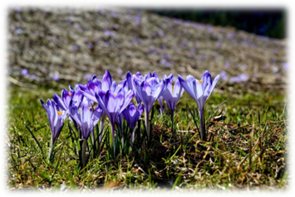
AMU International Students are invited to take part in a Welcome Centre Spring Trip to catch the Crocus flowers blooming in the Tatra Mountains (resort town - Zakopane), visits to Wieliczka Salt Mine, former Nazi concentration camp in Auschwitz and the ancient city of Kraków.
Accommodation, group insurance, private bus transport and selected group meals are covered by the University.
Your participation cost: 400 PLN/person, in cash at registration for the trip.
Registration in-person only, with 400 PLN payment in cash, to secure your spot, at:
- AMU Welcome Centre, open Monday-Friday, 8:00 – 16:00 (location: ul. Św. Marcin 78 - corner with ul. Kościuszki), street-level entry, corner of the building through sliding glass door.
Registration deadline: March 20th (Monday), 16:00.
The number of places is limited, so it is better to hurry up and book your place today!
See detailed program below:
*Each year about 120 million crocuses bloom in different parts of Tatra Mountains in the end of March and first weeks of April (depending on the weather conditions) providing spectacular views!

Trip tentative itinerary:
30 March  Thursday | 6:15 am - meeting at Adam Mickiewicz Sq.  6:30 am - departure from Poznań  13:00 - visit to Auschwitz-Birkenau memorial and museum  16:00 - departure from memorial  18:30 - check-in and dinner in the hostel in Zakopane
31 March  Friday | 8:00 am - breakfast in the hostel  9:00 am - trekking to Tatra Mountains depending on crocuses availability and weather:  - Polana Chochołowska or Kalatówki valley or  - Morskie Oko mountain lake  17:30 - dinner in the hostel in Zakopane
1 April  Saturday | 7:45 am - breakfast in the hostel  8:45 am - visit to Gubałówka Hill  11:00 - departure from Zakopane  14:00 - visit to the Salt Mine in Wieliczka  17:30 - check-in and dinner in the hostel in Kraków
2 April  Sunday | 7:45 am - breakfast in the hostel  9:00 am - Kraków - sightseeing: Jewish District (Kazimierz), Wawel Castle Hill and Old Town (Stare Miasto)  13:00 - free time (for lunch or shopping)  15:00 - departure from Kraków  21:30 - arrival to Poznań
Attention! Hours of the itinerary might change during the trip.

Trip coordinators: Marcin Witkowski (Welcome Centre), Paweł Sowa (International Office)
For questions, please contact: welcome@amu.edu.pl

